Annual Report to the Advisory Board
Cornell Prison Education Program
Prepared by Rob Scott
Fiscal Year 2024

This report references a few developments before July 1, 2023, but none after June 30, 2024.

Budget/Funding

The Cornell Prison Education Program had the funding it needed to maintain acceptable programming levels during 2023-24, and at time of writing we anticipate funding for equivalent programming in 2024-25; projected numbers are noted with an asterisk. We have uncertainty beyond 2025…

Revenue/Funding available

Account AY’23 AY’24 AY’25
CPEP Endowments $92,000 $146,000 $170,000
CPEP Current-Use Gifts $543,000 $815,000 $629,000
CCC Partnership -- $148,500 $150,000*
Ascendium Grant $131,451 $174,901 $192,000
Mellon Foundation Grant $1,750,000 $915,000 $550,000*

These numbers represent the available funds in the different accounts on July 1 of each fiscal year. All funds have restrictions, of course. The funds are organized from most sustainable to least, with endowment revenue being our most sustainable source of funding, and the Mellon grant clearly ending sometime within calendar year 2025.

Expenses

Account AY’24 AY’25
Staff (Salary & Benefits) $796,000 $850,000*
Instructors $292,000 $300,000*
Materials $146,000 $150,000*
Events/Space/Travel $61,000 $50,000*
Contractors $66,000 $66,000*
Indirect Costs $41,000 $45,000*

Total expenditures were $1.4m in AY’24 and we need minimally $1.46m to maintain the existing initiative in AY’25.
Political Developments

National/Federal

The major development of the preceding academic year in the field of Higher Education in prison (HEP) is that the process by which the U.S. Department of Education (DOE) was to re-instate Pell Grant eligibility for incarcerated college students essentially collapsed under the weight of its bureaucratic requirements. As a result, the already difficult task of coordinating college in prison was made all the more difficult as programs across the country took on this immense bureaucracy, expecting the modest reward of a partial Pell Grant for some fraction of their students, but in almost all cases there was no such revenue. Simultaneously, private funders increasingly halted contributions to HEP programs under the understanding that Pell Grants had returned.

To our knowledge, not a single new program was approved to receive Pell Grants for incarcerated students before the Fall 2023 deadline, and only one (1) new HEP program was approved to receive Pell grants in spring 2024, with zero (0) new programs approved by July 1, 2024. CPEP is among the programs that were still awaiting approval.

The most specific impact for Cornell is that the Mellon Foundation has communicated that they will no longer provide CPEP grant money to support the cost of offering courses in prisons. They have provided as much as 2/3 of our budget in recent years, so without any Pell revenue coming to Cornell or our partners at Cayuga Community College, there will be a significant budget gap.

New York

In January 2024, NY Gov. Kathy Hochul quietly announced the closure of “four or five” correctional facilities in the State of New York. The announcement was made by including funding for the costs associated with prison closure in the proposed executive budget. There were no headlines about this in the budget reporting, but the correctional workers within the state are aware.

There has been a staffing shortage and a high number of empty beds in the NYS prisons system for several years — this pattern was exacerbated by the release/parole decisions made during the first year of the COVID pandemic (2020-21).

Between January and June of 2024 no prison closures were announced, but many correctional officers looked for other work that would allow them to avoid a forced re-assignment when the closures inevitably occur. This likely created a positive feedback loop, where correctional officers leave their DOCCS job, thus making conditions worse for those who remain, thus creating an incentive for others to leave. It was not uncommon to go into these prisons and have every single C.O. that we encountered talk to us about being forced to work double-shifts, forced to work overtime (or “getting stuck” as the call it), working ten days in a row, etc. As more people leave the workforce an understaffing crisis mounted that threatened to make it impossible to offer courses in the school buildings, or at minimum required a day-by-day wait and see approach to whether there was sufficient security staff to host courses in each prison. This wreaks havoc on teaching and curricular continuity. It also can void the terms under which students are awarded financial aid. It is another existential crisis for the HEP community in NYS.

Academic Programming in the Prisons

Alongside the multiple graduations noted below, there were slightly fewer credit-bearing course offerings in AY’ 23-24 compared to earlier years. This derives from two dimensions of financial aid funding that converged upon us during this particular year. First: we began to require course enrollment dynamics that will be necessary for the financial aid era to provide sufficient funding for courses, namely requiring students to take at least 2, preferably 3 or 4 courses at a time to maintain enrollment while at the same time only offering courses which will fill up with at least ~15 students per class. Second: we were disappointed again and again to find that our financial aid eligibility was delayed, thus we delayed the process of admitting a cohort of new students while simultaneously our last grant funding for course costs while we wait.

In short, we can no longer offer courses with fewer than 10 students in them and we can no longer offer continued enrollment to students who refuse to take more than one course at a time. Enrollment dynamics such as these may have inflated our numbers in the past.

Between Fall 2023, Spring 2024, and Summer 2024 we hosted 80 weekly academic offerings at the three prisons we operate within (see Tables 1-3 at the end of this report). Of these, 52 were credit-bearing courses with the following distribution:

- 22 courses in Fall 2023 (7 at ACF, 9 at CCF, and 6 at FPCF)
- 23 courses in Spring 2024 (6 at ACF, 9 at CCF, and 8 FPCF)
- 7 courses in Summer 2024 (2 at ACF, 3 at CCF, and 2 at FPCF)

Put another way:

- Auburn Correctional Facility (ACF) hosted a total of 15 credit-bearing classes.
- Cayuga Correctional Facility (CCF) hosted a total of 21 credit-bearing classes.
- Five Points Correctional Facility (FPCF) hosted a total of 16 credit-bearing classes.

These numbers will likely be somewhat higher when we can start a new cohort of students who can receive Pell Grants. As of now, we do not anticipate any Pell Grant revenue to Cornell or our SUNY partners during the year ahead (AY’ 24-25). This means that every course that we run is being paid out of individual gifts to Cornell, and we will need to make them count! (Full-time degree-seeking students, in fully-enrolled classes, at least for the courses we pay for.) We continue to welcome volunteer instructors during this period.

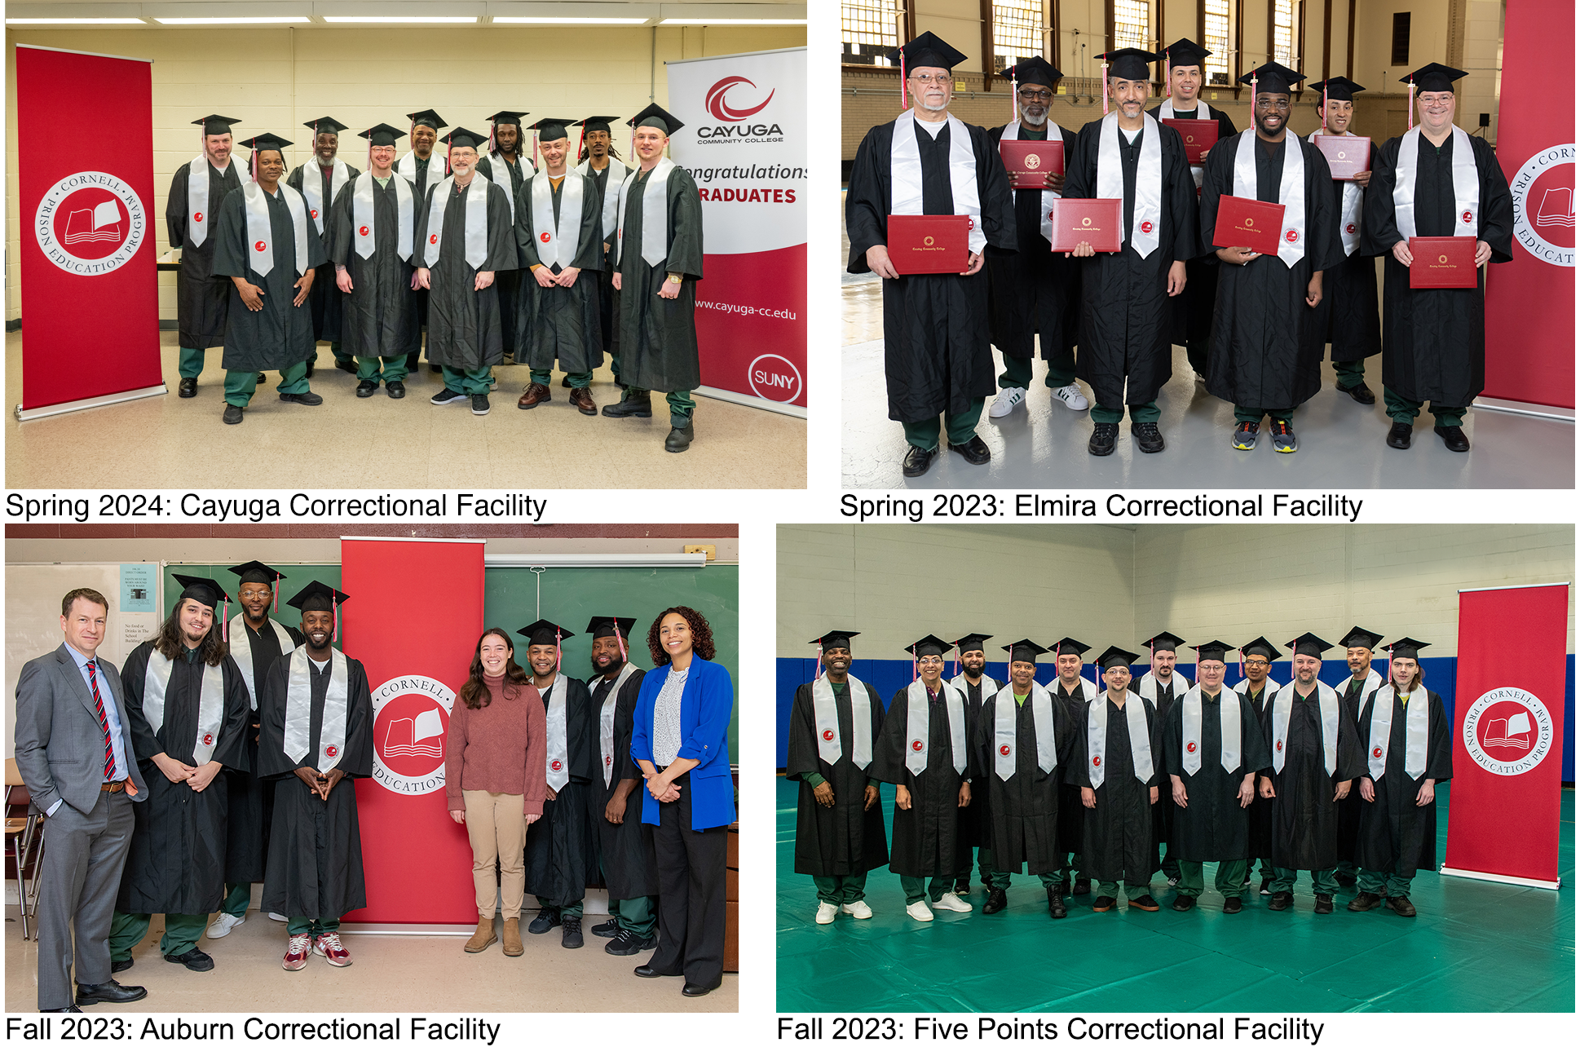

Images: CPEP hosted graduation ceremonies at four prisons between May 2023 and May 2024 – note that not all graduates are shown due to transfers, and some graduates opting out of photography. It was a veritable year of graduation ceremonies, in stark contrast to the shutdown of such events just a few years earlier during the pandemic.

CPEP Staff

We had 10 FTE staff on the CPEP Team for most of 2023-24.

Dr. Molly Reed announced her departure from the role of Cayuga CF Program Coordinator in July 2023 and Dr. Rachael Fieweger was hired to as our new program coordinator in August 2023.

Richard Rivera departed the role of Associate Director of Academic Reentry Services in February 2024; Sarah Cushman was hired as Reentry Associate in April 2024.

Cathi Root departed the role of Office Coordinator at the end of her term on June 30, 2024, after almost nine years of service. Most of her responsibilities had already been re-assigned to other team members in the preceding years and she was working half-time (or less) during her final year at CPEP. This position has been eliminated and we will not hire a replacement at this time.

Due to the elimination of the Office Coordinator position, CPEP will have 9 FTE staff during 2024-25 (see photo).

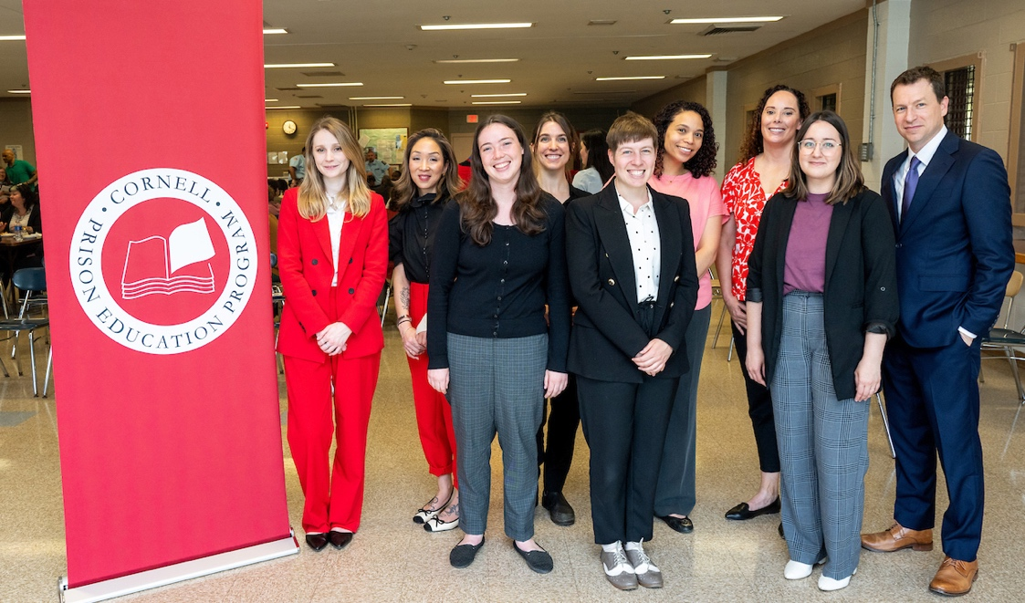
Image: The current nine CPEP team members pose for a photo at Cayuga CF graduation ceremony, May 2024. Left to right: Rachael Fieweger, Betsye Violette, Sage Weber, Tess Pendergrast, Maddie Reynolds, Keisha Slaughter, Sarah Cushman, Susanna Hempstead, Rob Scott.

CPEP Reentry Initiative

The CPEP reentry initiative went through substantial changes during AY’24, Richard Rivera’s departure greatly changes things. Sarah Cushman recently joined as a half-time Reentry Associate and will likely be promoted to full-time within AY’25. Both Richard and Sarah went through an experience of incarceration, and college was an important part of their journey to the present. Where Richard aspired to do big things and was often brainstorming new initiatives, Sarah has brought an attention to detail and a knack for following through with everything that was committed to.

Though she is not restricted to reentry work, Betsye Violette is very involved in the post-incarceration return to college enrollment, and coaching alumni on technology and job search. She also negotiated a discounted rate on 100 chromebooks (laptops) for returning citizens.

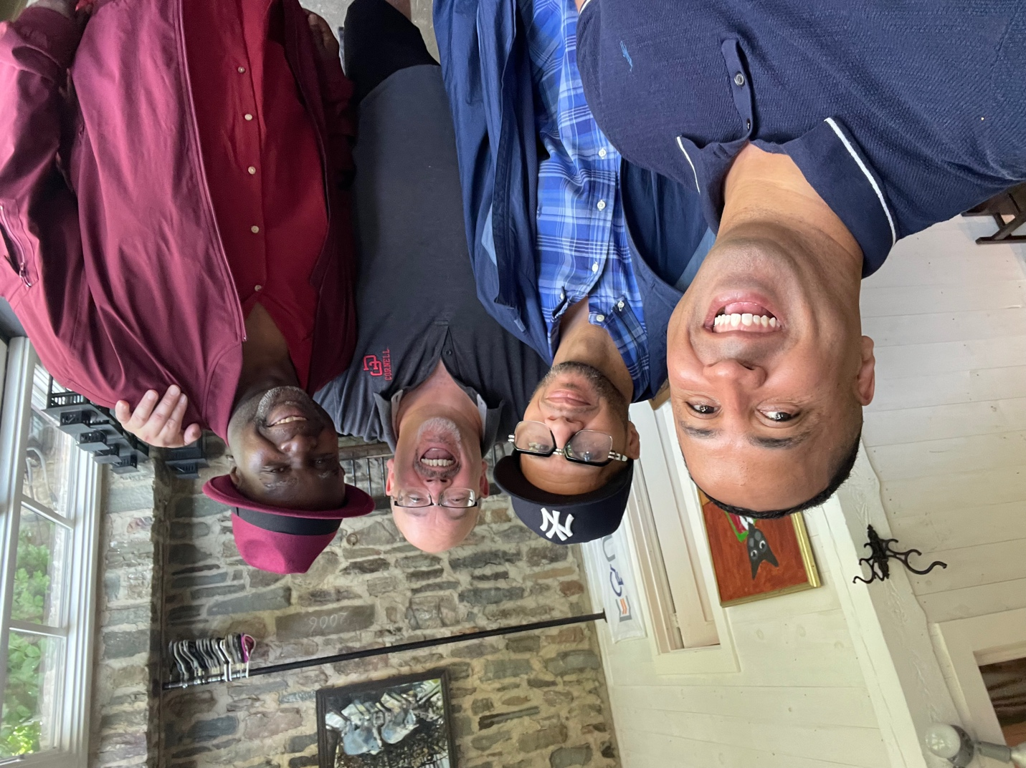
Image: Darnell, Richard, Ray, and Michael pose for a selfie at CPEP Alumni Reunion event in June 2024.

A distinguishing feature of our reentry effort is that we use a piece of software, the Education Justice Tracker or EJT, to anticipate parole release dates for students across the state, and we reach out to them even if they haven’t heard from us in years in order to insert ourselves into their reentry planning/journey.

A key lesson that we’ve taken from the experience of the past year is that we need to be crystal clear about what we are offering and what we are not offering. We cannot send letters into prison, on Cornell letterhead, saying “we will help you find a job” because that is far too vague. It is much better to say “we will help you format your resume” or “we will help you set up a linked in account” etc. and generally to limit ourselves to concrete and discrete forms of support than can be clearly accomplished. Blanket/vague offers to “help” with food, housing, transportation, family relationships, employment, parole navigation, etc. can all be sources of real frustration for people when things don’t work out.

The other side of this lesson is that if we don’t promise someone a job, but then find a potentially good job opening, it is then framed as “above and beyond.”

Some of the clear things we can offer at the outset include a no-cost chromebook, an informed planning process that will help our alumni self-facilitate their transition, and referral to basic services that are provided in several of the main cities to which our alumni return. We also host occasional events to provide a context for networking, and use an email list to inform alumni of opportunities and resources as we learn of them. The Department of Corrections has signaled that they will allow us to send Sarah inside Cayuga CF in the 3 months before our alumni are released for in-person planning and advising so that we can begin our reentry work before release.

CPEP Librarian

Maddie Reynolds joined CPEP as an Assistant Librarian (based out of Olin/Uris Libraries) in 2022, and she contributed greatly during AY’24. Additionally, Cornell University Librarian Elaine Westbrooks has taken great interest in the CPEP library effort and has pledged to try to fund the CPEP Librarian position beginning in 2026. Meanwhile, Maddie continues to lay the groundwork for the library work that will perhaps be most important for the launch of a bachelor’s degree initiative (anticipated in AY’26).

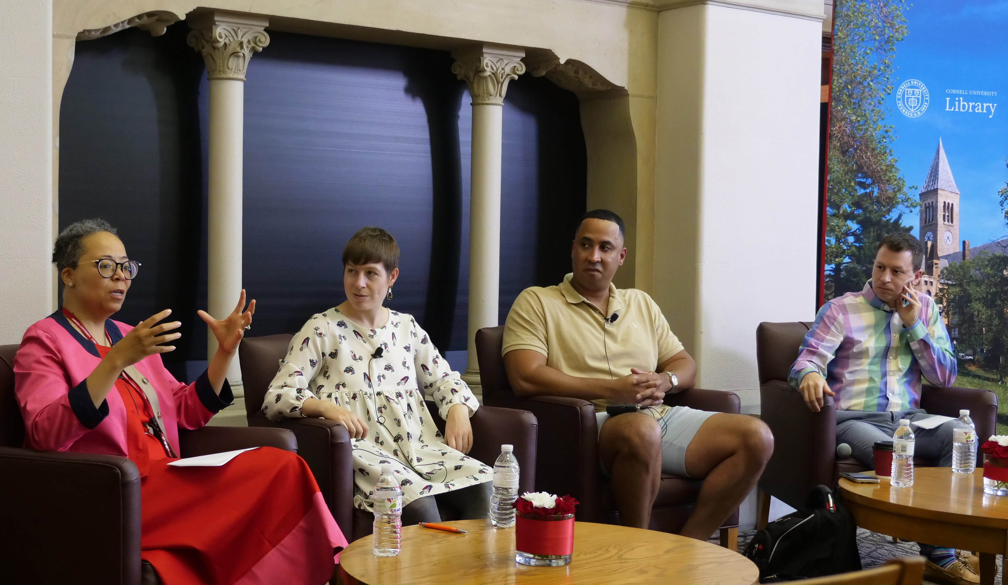
Image: Cornell University Librarian Elaine Westbrooks speaks during a panel with Maddie Reynolds, CPEP alumnus Darnell Epps, and Rob Scott in June 2024.

During the past year, Maddie facilitated installation of an offline JSTOR index in the (internet-free) prison environment, allowing incarcerated college students to search this research database for scholarly articles and expand the intellectual horizons of the college program. She also proposed, acquired, and installed a small academic book collection in each of the three prisons, working within a budget provided by CPEP. These books expand the existing liberal arts curriculum we offer through courses in the prison, allowing students to have a life of the mind beyond the current associate degree offering.

Maddie also facilitated multiple writing workshops, funded by a grant she was awarded, which will culminate in the publication of our incarcerated students’ written work. Finally, she worked with board members to acquire an additional grant to create an archive of CPEP materials in the Cornell library.

CPEP Research Initiative

CPEP Research Associate Tess Pendergrast and Assistant Professor in the Brooks School of Public Policy Sadé Lindsay have been co-leading a research protocol entitled, “College education attainment inside New York state prisons and post-release: exploring impacts, opportunities, and barriers,” since Spring 2023. As part of this project, Dr. Pendergrast and Dr. Lindsay have worked on a study of reentry experiences for former CPEP students. They have collaborated with CPEP staff, including reentry directors/associates and the associate director of student services, to conduct focus groups and use questionnaires with previously incarcerated CPEP students.

Over approximately 18 months, the research team conducted interviews with 25 released CPEP students. The questionnaires used by the team were designed to be given to individuals soon after release from incarceration and 6-12 months after release. Questions included topics on financial and technological literacy, housing, educational and professional aspirations, employment, and mental and physical wellness. The two-part design helped the team see what changed for individuals over time and whether/how reentry efforts were able to improve specific outcomes.

The study has helped inform some of the reentry team’s approaches this year. Additionally, the research team is finalizing a report based on the findings that will be sharable with staff and the board. The team also plans to use findings towards peer-reviewed papers with anonymized data, to add to literature on reentry and the impacts of college-in-prison initiatives.

Figures and Tables

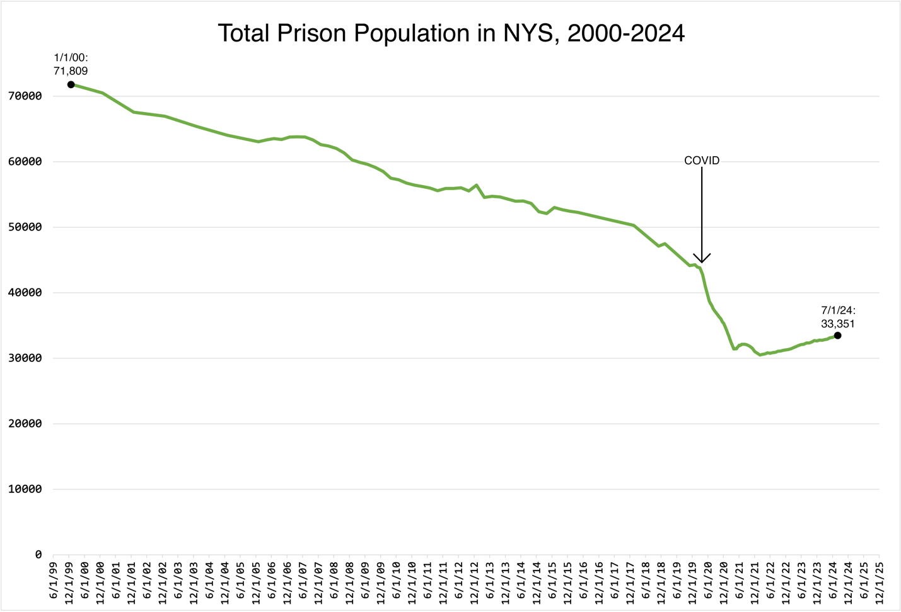

Figure 1. The state prison population for New York remains much lower than it was at the peak of mass incarceration, and a few thousand above the low point of the pandemic. Anecdotal observations from the prison environment suggest that the remaining population will be more difficult to decarcerate due to longer sentences, but also potentially worse challenges in terms of trauma and mental health, poverty, behavioral dysregulation, and absent family/social supports.

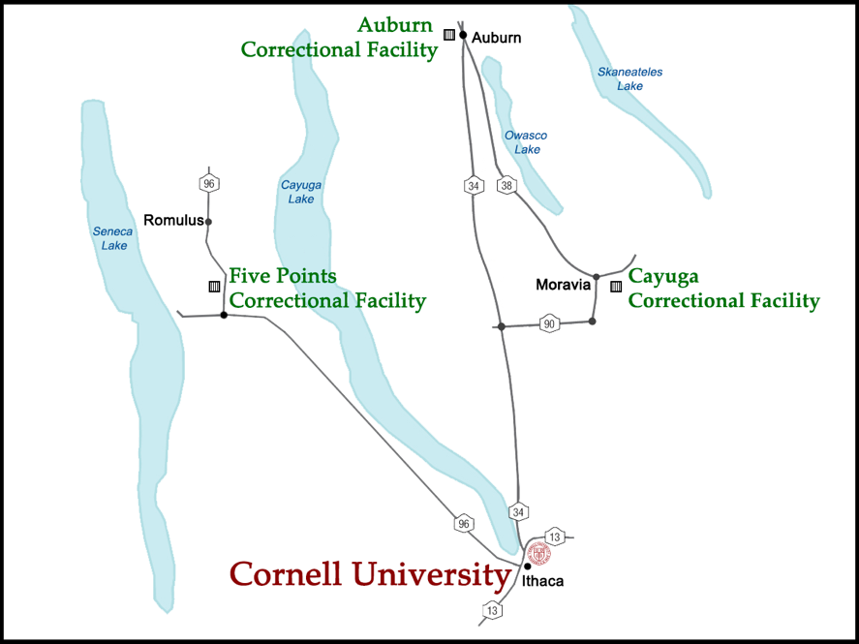
Figure 2. CPEP operates in these three prisons (Auburn, Cayuga, and Five Points). The only other prison within a one-hour drive of Cornell (Elmira) now has an associate degree program operated independently by Corning Community College.

Fall 2023 Courses by Prison

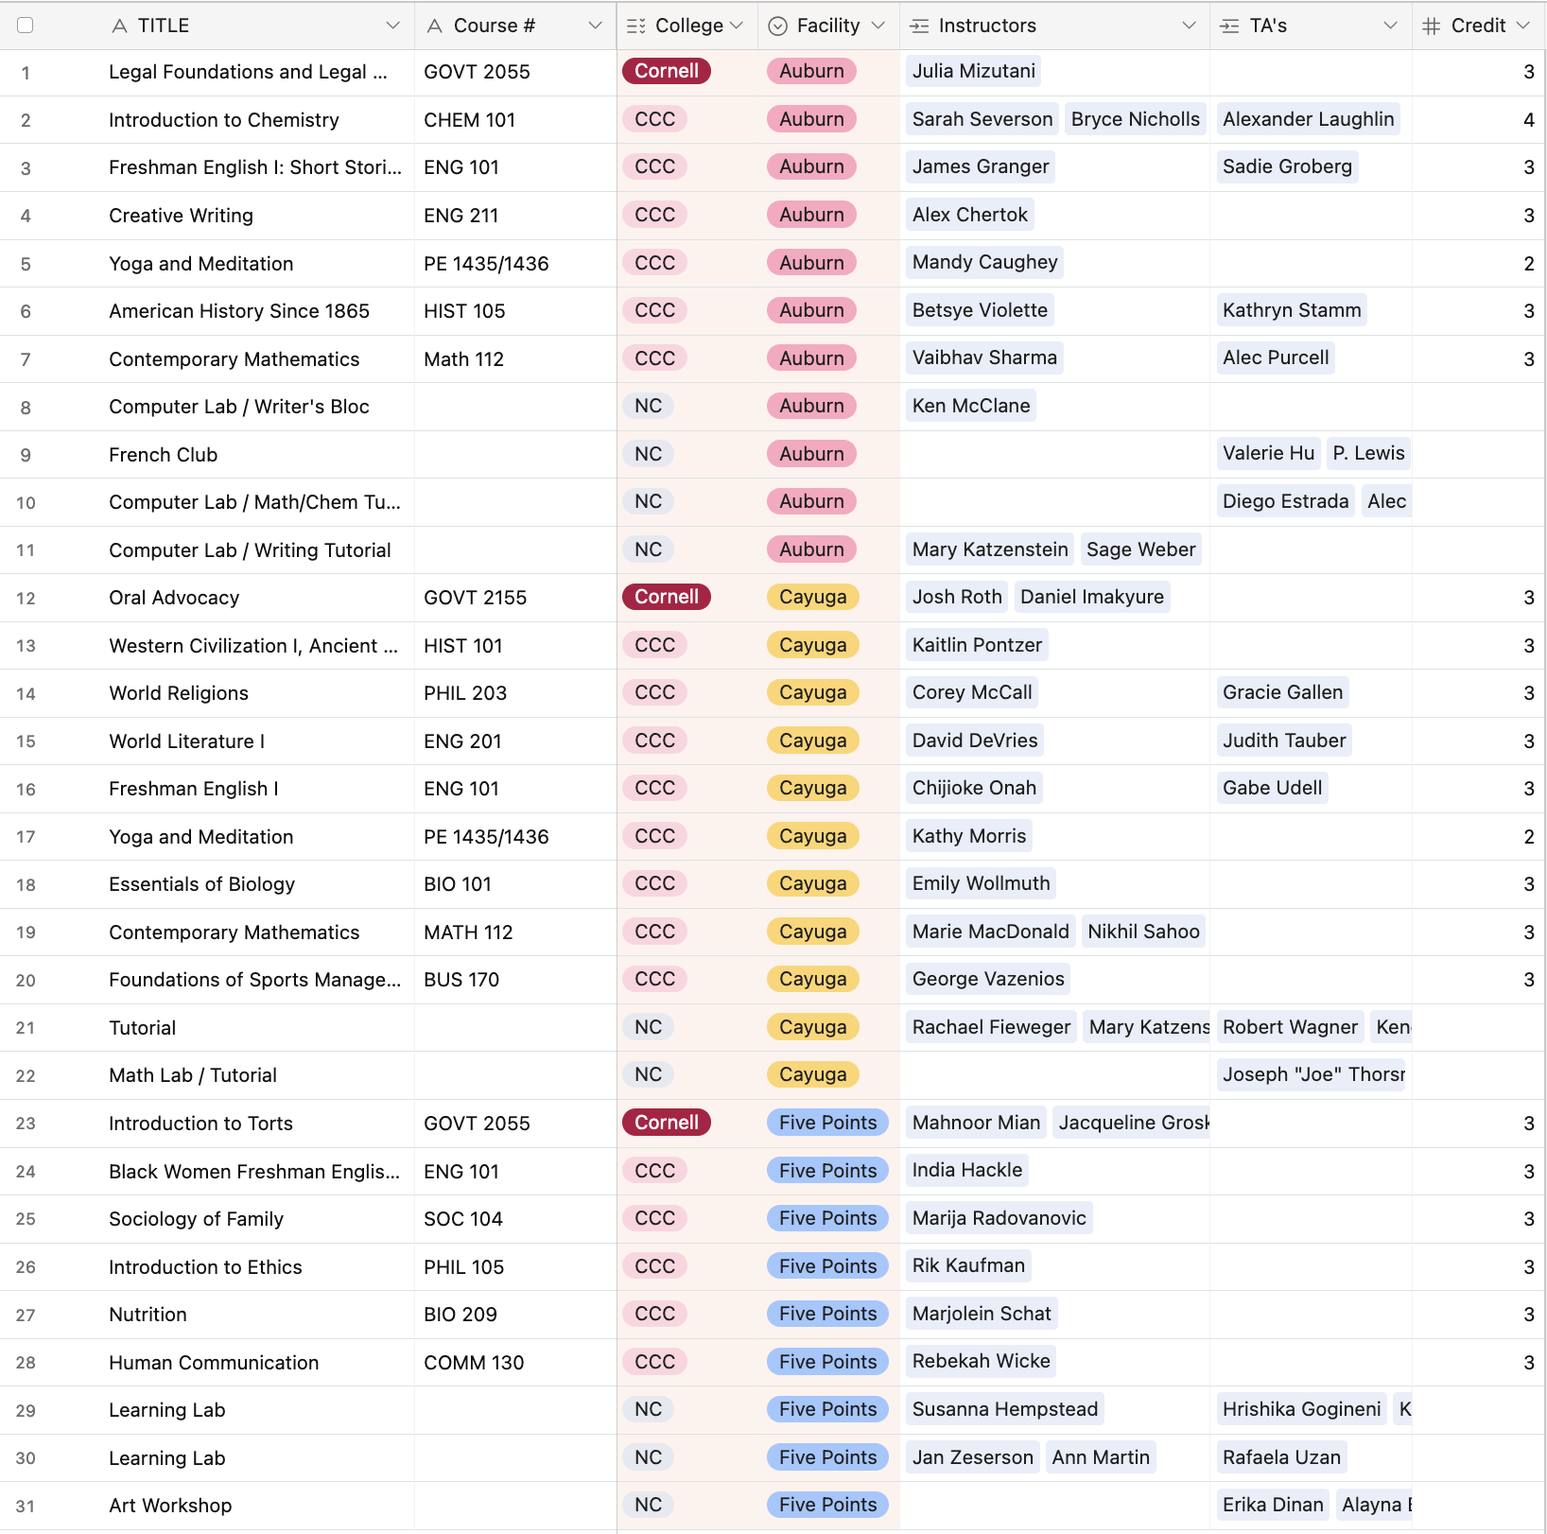

Table 1. Fall 2023 academic offerings across the three facilities.

Spring 2024 Courses by Prison

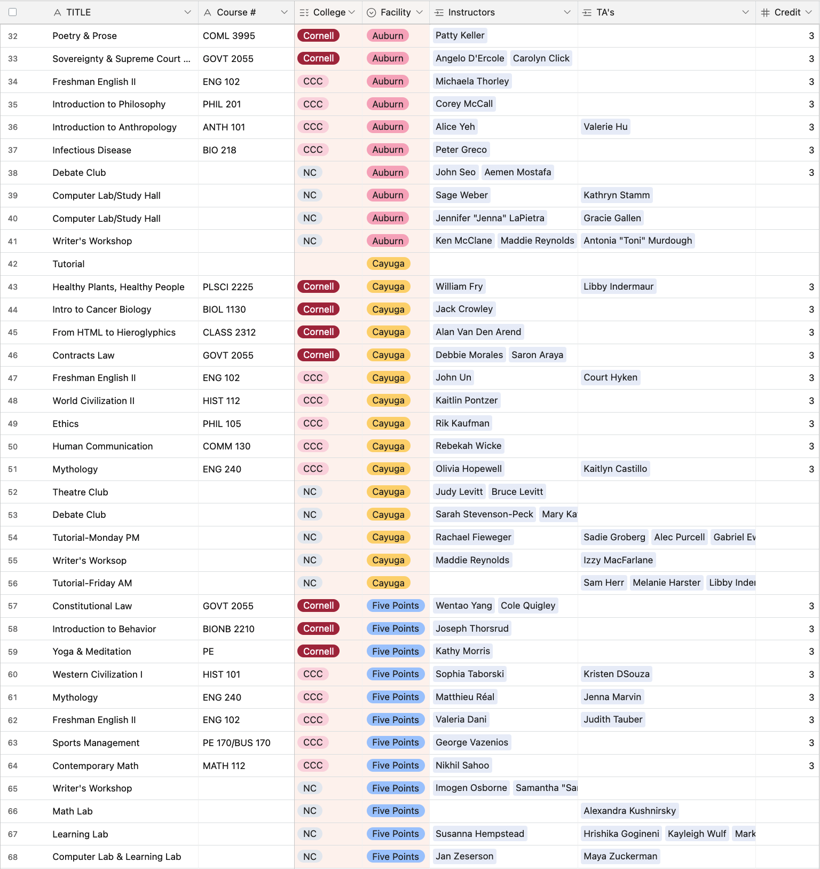

Table 2. Spring 2024 academic offerings across the three facilities.

Summer 2024 Courses by Prison

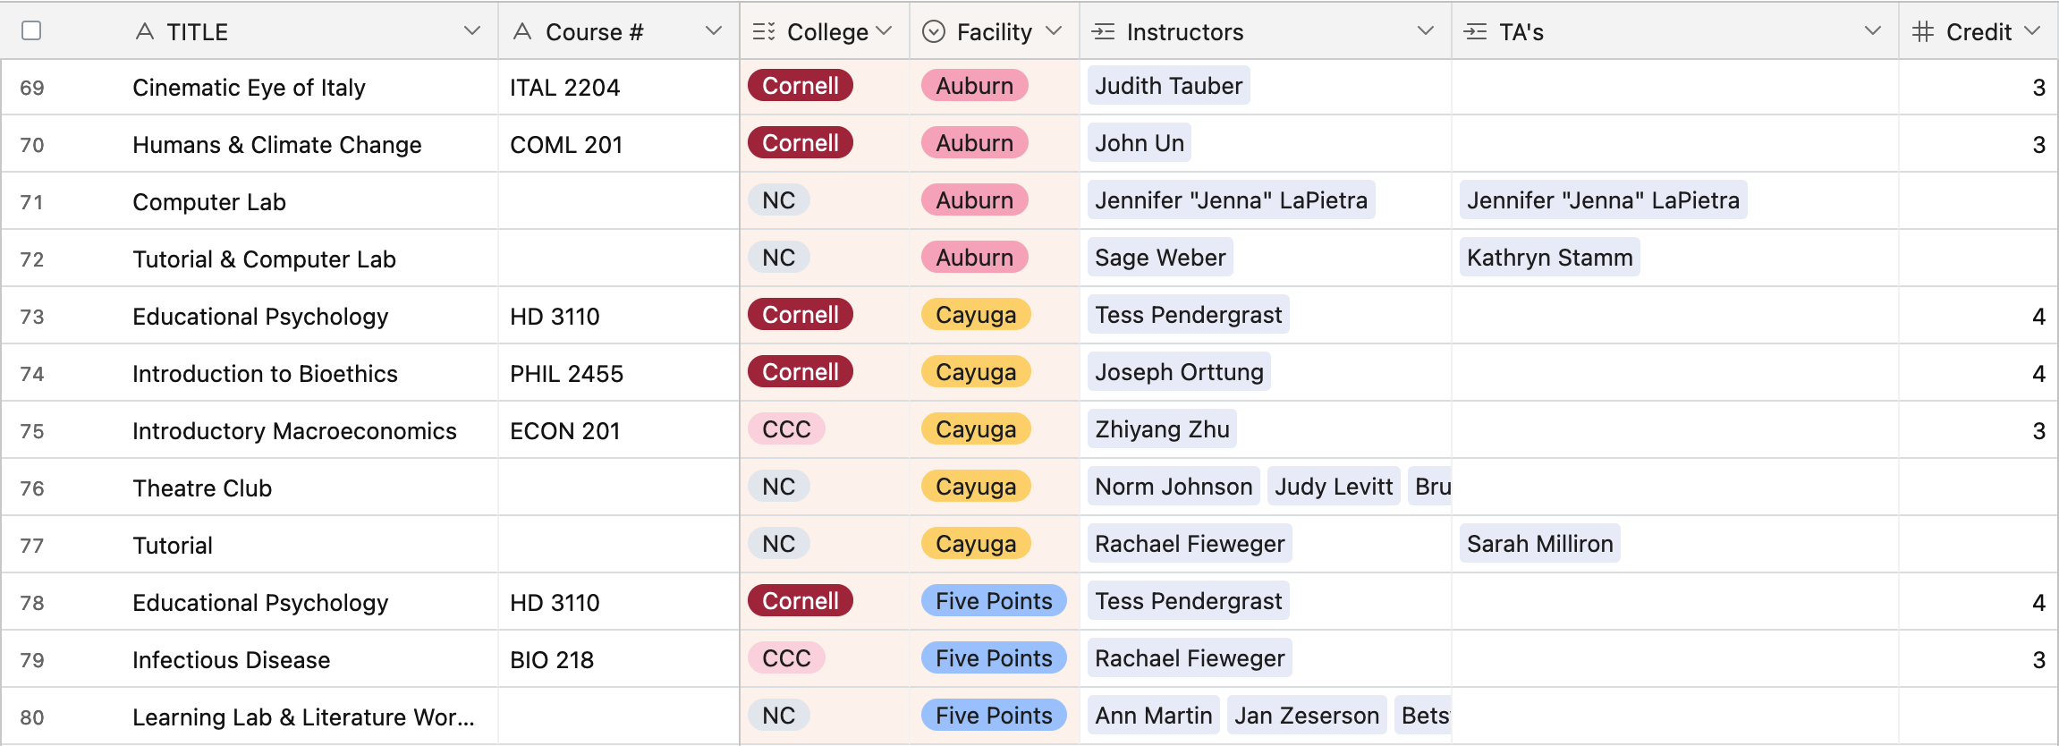

Table 3. Summer 2024 academic offerings emphasized courses registered through Cornell University and non-credit courses, due to the complications caused by initiating CCC tuition billing in anticipation of Pell Grants, but then receiving no Pell grant revenue during 2023-24 due to the delays in the process of registering CCC as a Pell-eligible HEP program.

